URL: <http://www.drcerny.co.za/>

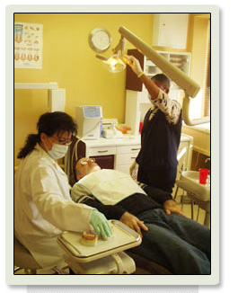 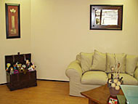 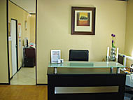 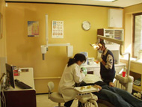

Dr Cerny has been practising dentistry since she graduated at Belgrade University in 1990 and she focuses on affordable painless dentistry. When you contact Dr Cerny, she will be able to give you a diagnosis and treatment options of any dental treatment you need to have done.

What makes this professional clinic the wise choice is that all the services are delivered at Medical Aid Rates +10%. Please note Dr Cerny is contracted out. The account needs to be settled after service. This is a major bonus considering what other dentists in South Africa are charging for dental treatments.

**Mission:**

**To provide an excellent dental service to adults and children**, at competitive prices, within a pleasant environment, with the major objectives of improved dental health and enhanced trust in the Dental Profession.

**Dental services:**

• **Restorative Dentistry** – mercury-free dentistry, porcelain restorations such as [crowns](http://www.drcerny.co.za/crowns.htm), bridges, ceramic on lays, inlays, and porcelain veneers;

• **Prosthetics** – removable dentures such as full upper and lower dentures and all types of partial dentures;  
 • **Pedodontics** – a traumatic dental treatment suitable for the kids (milky and mixed dentition);  
 • **Oral Surgery** – such as simple extractions, surgical removals of erupted and impacted teeth;  
  • [Teeth Whitening](http://www.drcerny.co.za/DentalServices/teeth-whitening.htm) - we will whiten your teeth with quick, painless teeth whitening procedures that suite you.  
  • **Dental Implants** – dental implantology is a new branch of dentistry which involves the reconstruction of missing teeth and their supporting structures with natural or synthetic substitutes;  
  • [Cosmetic Dentistry](http://www.drcerny.co.za/cosmetic_dentistry.htm) – bleaching procedure and all types of aesthetic restorations;  
 • **Endodontics** – root canal treatments;  
  • [Periodontology](http://www.drcerny.co.za/periodontal.htm) – both conservative and minor surgical corrections of supportive tooth tissue (periodontium);  
  • [Oral Hygiene](http://www.drcerny.co.za/oral_hygiene.htm) – education, oral hygiene instruction, scaling and polishing as part of all dental procedures.

**Painless Dentistry**: Pain-free and caries-free

* No anaesthetic, no drilling and no pain – also perfect for treating phobic patients
* No ailments following treatment
* Considerably reduces the need for fillings
* Maximum retention of healty tooth substance
* The treated tooth is more resistant to caries attacks

**Testimonials**

**Gabriella**

I would just like to thank you for giving me a beautiful smile! I can now smile with confidence and that would not have been possible without your help. I love my crown more each day!

You are a gifted doctor and I now look forward to going to visit the dentist

**Nathan**:

I just wanted to say thank you very very very much for sorting out by dry septic socket ... my mouth is feeling a LOT better now.   
  
You are a true miracle worker - thank you.

**Francois Muscat, Kyalami:**

As with most people we tend to stay with one dentist for our whole life.

When my dentist closed his practice, I was left with the task of finding a new dentist.

Well, I tried a new dentist and was disappointed as he seemed more interested in golf that my oral hygiene.

A client introduced me to Dr Aleksandra and what a surprise.

She is a consummate professional and I felt totally at ease in the chair.

She kept me informed during the entire appointment and worked out a maintenance plan for me.

She has a great sense of humour as well and I must say that I really enjoyed my dental appointment.

I have no hesitation in recommending Dr Aleksandra  to anyone of my friends

**Mr Trevor Bezuidenhout, Moreleta Park, Pretoria:**  
"Worthwhile travelling all the way down the N1 for excellent, professional and painless service!!!"

**Credentials of doctor cerny** 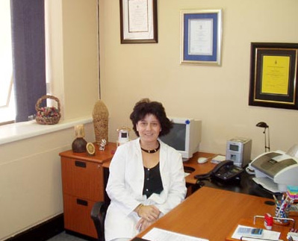

Dr Cerny graduated with a Bachelor of Dental Science Degree at Belgrade University in 1990. She is a member of dental societies both in RSA and Serbia.

Dr Cerny is a member of the SA Dental Association, and a registered Dental Surgeon with the South African Medical Dental Council.

In 2003 she was awarded a Post Graduate Diploma in Dentistry (Dental Implants) from Stellenbosch University.She has been a practicing dentist since graduation and has extensive experience worldwide. The main focus within her clinic just outside of Sandton is to keep the dentistry painless.

**Contact us:**

**Tel (w):** +27 11 465-6686

**E-mail:** [aleksandra@drcerny.co.za](mailto:aleksandra@drcerny.co.za)  
**Lonehill Dental Clinic**:  
Dr Aleksandra Cerny  
Suite 100A  
Lonehill Shopping Centre